**Hyperledger Composer**

Deploy a Car Auction Business Network

Description: In a car auction, the price of your car is set by the company itself. Therefore, there is always a mediating or commission fee involved. Instead, we can create an interactive decentralized auction network where the highest bidder gets the car.

Steps to perform:

* Create a new participant in the Auctioneer participant registry

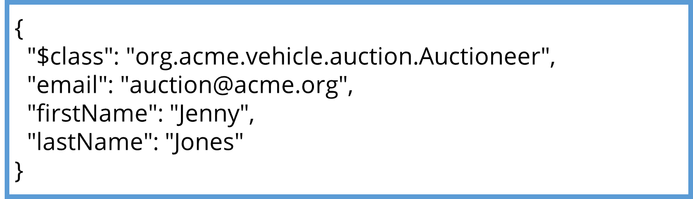

* Create two participants in the Member participant registry

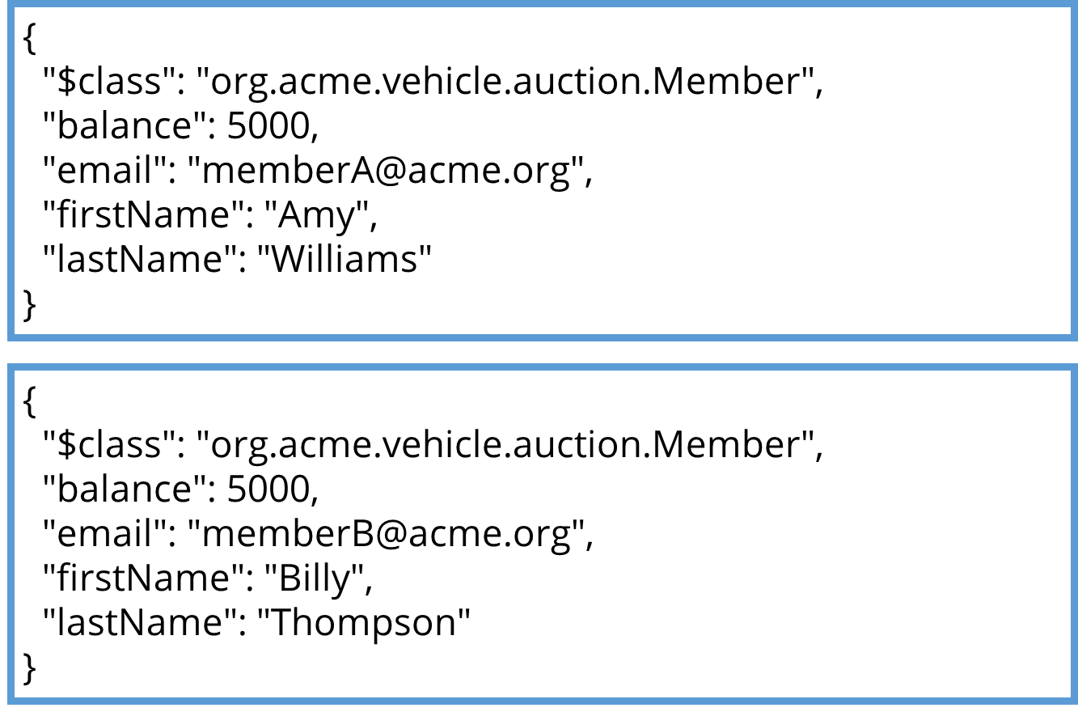

* Create a new asset of vehicle owned by memberA@acme.org in the Vehicle asset registry

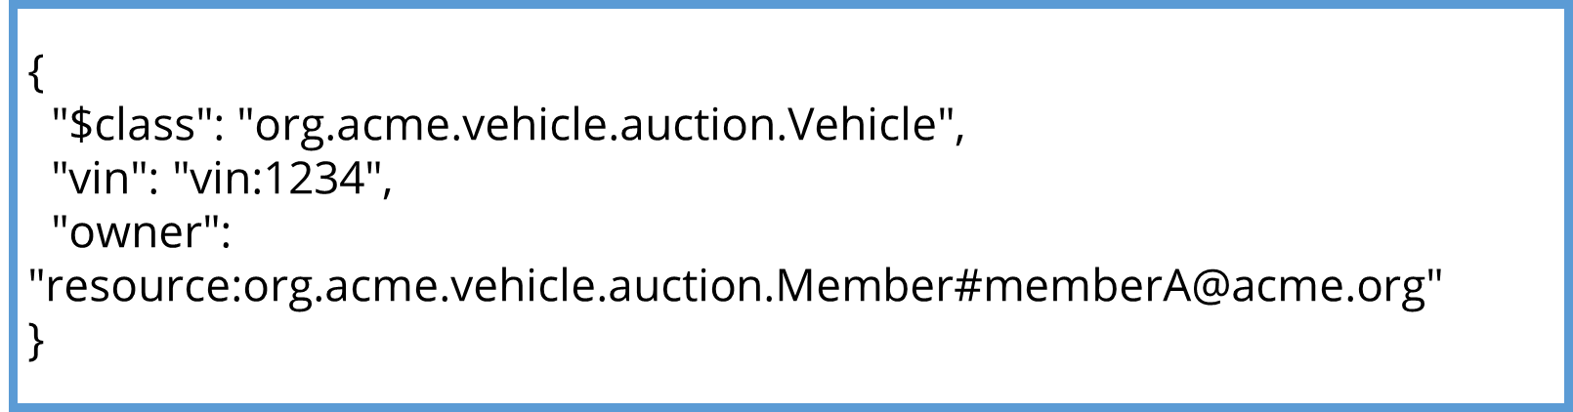

* Create a vehicle listing for car vin:1234 in the VehicleListing asset registry

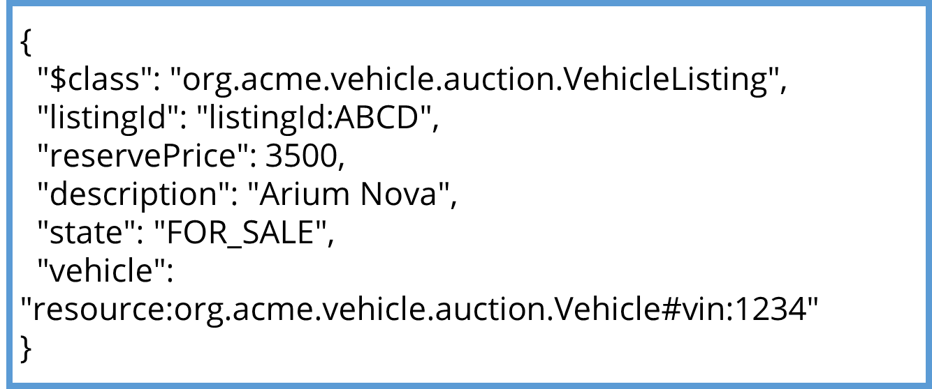

* Submit an Offer transaction

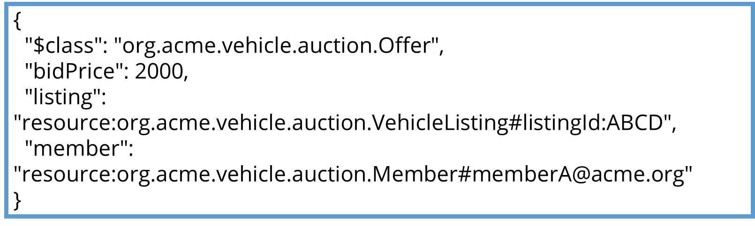

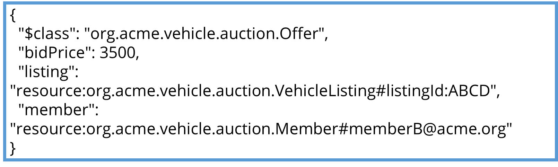

* End the transaction

